29 January 2020
JHJ+SHL
National Accounts

Balancing the SUT

Having populated an initial SUT with the “best” available figures in the sense that all possible data sources have been used, properly coded and even sometimes recoded, it is time to move on to the process of balancing.

The process of balancing proceeds in three steps. We refer to the first two steps as the manual balancing steps:

3 steps in the
Balancing process
- Elimination of product imbalances
- Balancing in the direction of the Target totals
- Final balancing

Data in different
price levels and the
“bridge column”
Before proceeding it is important to recall how the SUT is fulfilled. All data on the supply side is valued at basic prices. All data on the uses side is entered as values at purchasers’ prices. To connect the supply side with the use side at a comparable price level, it was necessary to build a bridge between the two sides. This is primarily done by building “models” for distribution of margins and taxes by uses and products. In practice assumptions about trade margins, tax and sales-tax -rates is entered in specific columns in the SUT-workbook. Then the use of formulas automatically calculates the values in the margins-, tax on products- and VAT-layers. Adding up all trade margins and taxes for each product gives us the “bridge column” that brings up the supply side to purchasers’ prices.

Manual balancing in purchasers’ prices
Note therefore: In the manual balancing process, many corrections will be made on the use side and they should always be made in purchasers’ prices! When it is necessary to make corrections on the supply side, these are off course made in basic prices. But we end up by looking at differences between supply and use in purchasers’ prices.

Several people are normally involved in the manual balancing process. As a consequence it is very important that this part of the SUT-work is highly systematically organized. You will need a good practice for Folder naming, Excel-workbook naming, and a systematic and uniform way of describing and documenting your changes. If not, things can very easily become a mess, and you will lose track of how changes are made in the SUT.

When it comes to the final balancing, this will need to take place on a single computer. For practical reasons a single person should be appointed as responsible for the final balancing.

Organizing the PC’s and data
Right now, the SUT-work is organized with Folders like this:

C:\Georgia\SUT\
C:\Georgia\SUT\SUT-Indata – containing initial SUT-data
C:\Georgia\SUT\SUT-System – containing:
- SUT C 2017.xls – the current version of the SUT
- Targets Totals 2017.xlsx – the current version of the targets for the column totals in the SUT

Add to this a new Folder:

- C:\Georgia\SUT\SUT-Balancing

where one or more EXCEL-workbooks containing one or more sheets with various corrections to the SUT can be placed.

During manual balancing, every “balancer” participating in the balancing process, will always be interested in the newest version of the SUT where all changes are reflected – including those changes made of all other balancers.

This is off course not easy, when a network is absent. Instead, it would probably work fine with a fixed procedure which ensures a proper updating 2 or 3 times a day:

A procedure for keeping the system updated
- Appoint one person with main responsibility for maintenance of the system. We refer to this person as the “main-balancer”
- Be sure, that the specific “main-balancers” PC always contains the central “current version” of the system.
- In the morning, after lunch and before leaving the office, every balancer delivers a copy of the workbooks (with “final” corrections) in C:\Georgia\SUT\SUT-Balancing to the “main-balancer”.
- The “main-balancer” saves the corrections in “SUT C 2017.xls” and distributes a copy of the updated SUT to every balancer.
- The “main-balancer” should also keep track of any changes in the targets and be sure that every balancer has the newest version of “Target Totals 2017.xlsx”
- Continue balancing.

The above procedure will hopefully avoid confusion regarding which versions should be considered the “current” version.

Manual balancing
The column totals from the initial SUT is defined as the initial target totals and they are manually stored in the Excel-workbook “Target Totals 2017.xlsx”. They are named “Targets”, because they have to be considered as numbers, one is attempting to reach during the balancing process.

At a starting point, there are no difference between the column totals of the initial SUT and the target totals, simply because we have made a product-distribution for every column-total. Looking at the rows, comparing supply and use reveals, on the other hand, that every product is in imbalance.

When we start to balance every row and product, the column-totals will immediately begin to deviate from the target totals. How do we deal with this problem? The answer is that we have to modify our goal that every target total can be reached exactly. Therefore manual balancing can be defined as:

A working process where the balancers:

Definition of
Manual balancing

- Make every product balance – or almost balance - with total uses = supply, by making corrections either to the supply side or the use side. It is not necessary to remove any imbalance completely. Leaving the product with a small imbalance is quite acceptable – it can be balanced later on with automatic procedures.
- Redistribute products between uses until the sum of values in each column is within an acceptable distance from its target
- Adjust one or more target totals

The manual balancing is conducted by 3-4 people. There should be a limited number of participants and we recommend that about 3-4 people are directly involved in the balancing, to minimize the risk of confusion and that balancers corrections interfere with each other. But more people can be involved whenever there is need for scrutinizing specific sources and compilations.

Each person is responsible for:

Responsibilities of the balancers

- A complex of industries and categories of final use with a high degree of interaction.
- The products they have in common on either the uses- or production side.
- All products and categories of use have to be distributed between the balancers.

There are certain rules to follow:

Rules to follow
- All corrections are written in separate Excel-workbooks and stored in C:\Georgia\SUT\SUT-Balancing. Remember the SUT is updated by saving new figures in level, not by saving additional corrections to the original SUT-figures! Best practice is:
  - Retrieve the chosen NA-product from the SUT
  - Save the retrieved NA-product in one of your Excel-workbooks containing corrections.
  - Make changes to the figures you want to change. Write corrections in the cell by formula, so you can see the transformation from the old figure to the new.
  - Corrections should be explained whether independently motivated or motivated alone by the need to reduce or increase the total value in a specific use.
  - IMPORTANT: In the corrections sheets, delete all values that are not deliberately changed. If not, the system will not be able to calculate changes to trade margins, taxes, VAT and basic prices automatically. This can cause random, unpredictable and sometimes wrong changes to the figures.
  - Save the workbook.

- When products are balanced or almost balanced, be sure not to introduce new big imbalances.
- Net taxes on products other than VAT by product should be kept equal to their targets during the balancing process.

- Major corrections to values outside one’s own complex should be negotiated with the “owners” of the other complexes involved. Corrections to cells must be agreed upon so they only appear once – or are given the same values – in the correction sheets. Otherwise there will be confusion.

Targets to reach and targets less secure
An important issue is to know where to differ from the initial targets and/or where to correct the targets. In this context it is necessary to bear in mind how the different data sources are used to compile the totals and product structures for each individual industry, consumption group and the other categories of supply and use. Depending on the data sources both the targets and the product structures are more or less reliable.

Typically one will try to reach – within an acceptable distance – those targets that are most likely to be based on well-founded, solid statistics. In the Jordan case figures like “Import and Exports of Goods” are of a fine quality and “Production”, “Intermediate Consumption” and “Changes in inventories” are in most cases based on grossed-up surveys of a rather good quality. But off course in some areas the coverage may be inadequate, for instance within the informal sector or small businesses. Such uncertainties should be taken into account.

The initial values for GFCF are probably not so well founded, and in the end the distribution by products will have to be determined by the availability of typical investment goods. Household consumption expenditure is uncertain due to the immense grossing-up of the household budget surveys. The distribution on products does also seem less precise compared to other sources.

So a number of target totals can be corrected and - not least - their product distribution may be changed during the balancing process.

When we start…
Before starting balancing, responsibility concerning Industries and Products has to be established.

When the balancing of the products begins, remember the different possible causes for imbalance:

- Some cells are missing. The SUT is incomplete.
- Some numbers are not at the right level e.g. due to insufficient coverage
- We compare figures valued at different price levels e.g. due to problems with the layers for trade margins, product taxes and VAT
- The product coding is different amongst sources

Final balancing

…description will follow later

Annex 1. Use of buttons in the toolbars ”SUT-maintenance” and “Adjust”.

Edit personal settings. Used to choose drive letters and the name of the workbook from which data is extracted or to which data is saved. The chosen values must correspond to drives and a SUT-filename that actually exist! The choices can be used temporarily or they can be saved for future use by pressing either ‘”Use” or “Save”.

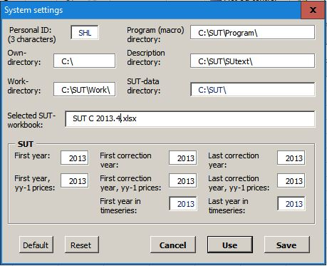

The “Reset” button will remove any changes made since the form was opened. The “Default” button will set all choices back to their default values. None of these buttons will change anything until the “use” or “save” button is pressed.

Extract one - or a range of - rows (product balances) from the selected SUT framework. Rows can be selected with the mouse by selection of a specific row or a range of rows. Pressing the button will open a form-window:

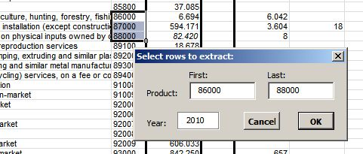

The selection of first and last row is shown in the form. They may be overwritten by a changed selection. When “OK” is pressed the rows from “First:” to “Last:” are extracted to a sheet in the standardized format that can – after editing – be used to enter corrections into the SUT-framework.

Extract one – or a range of - columns (industries, consumption groups or other columns) from the selected SUT-framework. Columns can be selected with the mouse by selection of a specific column or a range of columns. Pressing the button will open a form-window:

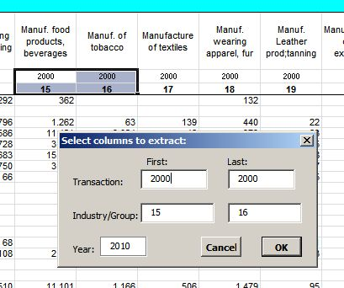

The selection of transaction codes and industry- or consumption group for the first and last column is shown in the form. They may be overwritten by another selection. If first and last transaction code are entered as “0100” and “2000” the extracted list will show outputs and inputs for each of the chosen industries. When “OK” is pressed the selected columns are extracted to a sheet in the standardized format that can – after editing – be used to enter corrections into the SUT-framework.

Extracted data for rows or columns are placed as Excel-workbooks in the directory selected as “Work-directory” in the “Personal Settings”-form (opened by pressing the -button). This directory should be cleaned regularly as it will otherwise be filled up with old temporary sheets. Extracted rows and columns will have this format:
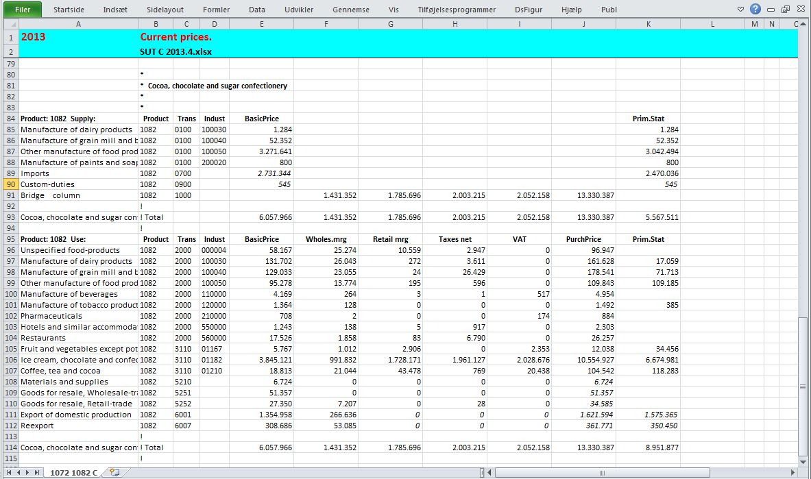
Values shown as italics are marked as “predetermined”, meaning that they are not included in automatic adjustments.

The same format is used when data is entered into the SUT-framework, but lines and values that are not explicitly corrected are removed from the sheet or “commented out” with an asterisk in column “B”:
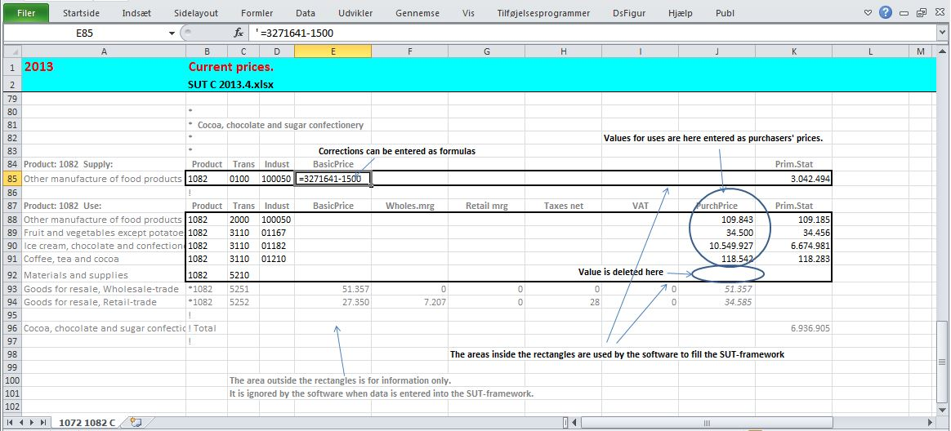

The following information from the input-data sheet is ignored when data is entered into the SUT environment:
- Blank lines
- Headers, lines with “Product” in column “B” and/or “Trans” in column “C”
- Text from column “A”
- Comments, lines with a leading “*” in column “B”
- Rows surrounding column-totals, lines with a leading “!” in column “B”

Values within the “rectangle” are entered into the framework where they replace the previous values at the same place. This applies to all levels from “Basic” to “Purch”. It is in most cases appropriate to enter values on the uses side as purchasers’ prices only. The software will then insert formulas that calculate the values in the layers from “Basic” to “VAT”. The formulas are based on a set of assumptions and may be overridden by constant values. It is, however, recommendable that this is only done where the formulas produce improbable results, typically for goods that have negative uses (scrap, sales of used equipment etc.). If corrections are written as italics they will be saved as “predetermined” values that are excluded from further automatic adjustments.

Test whether values from the active datasheet can be entered successfully into the SUT-framework. A sheet in the standardized format with corrections is read and validated. When a formal error or a code that cannot be found in the SUT-framework is encountered, an error message is added to the right of the data-line. Values for trade and transport margins, net taxes or VAT that can be determined implicitly are added to the input sheet.

Save values from the active datasheet into the SUT-framework. Use the “Test”-button first to make sure that the active sheet does not contain logical errors or invalid codes. Use of the “Save” button will repeat the validation of the corrections sheet, but will also enter the corrected values into the SUT framework. When cells for margins, taxes and VAT are left blank, these values will be calculated automatically by formulas using the default assumption build into the macros. If some margin, taxes or VAT values are entered as values instead of empty cells, the these values will replace the formulas.
Test modifications to rows. See whether an active sheet with instructions to add, delete or rename rows can be entered successfully. The datasheet should have the following form:

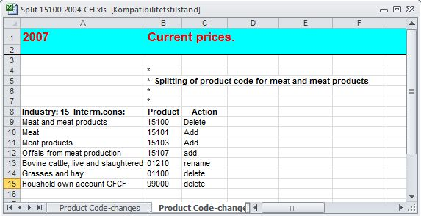

Add modifications to rows. Add, delete or rename rows in the chosen SUT-environment as described by instructions in the active data-sheet. Use the test-button above to make sure that the instructions can be entered successfully. The corrections will affect all layers of the SUT-system. New rows will contain the same formulas for calculation of totals as the surrounding rows, but will not contain values until they are entered form a standardized corrections sheet.

Vertical-horizontal adjustment. Proportional adjustment of column-/row- values to column-/row-targets. Adjustments are limited to the selected areas in the SUT. Predetermined values – values shown as italics – are left unchanged.
Automatic changes will only take place where the adjustment factor can be kept within the interval from 0.2 to 5.0 .
A comprehensive description on selection of areas of varying shapes can be found in the explanation to the button: “Selection tool”

At this moment six adjustment methods are available:
- Vertical
- Horizontal
- RAS area
- RAS totals
- Final uses
- Use >= Stat

On the supply side all adjustments take place at basic prices.

On the uses side:
Vertical adjustment of column-totals to column-targets take place in purchasers’ prices as this is the value concept for which primary statistics is available.

Horizontal adjustment of row-totals of the use table to the supply-totals from the supply table is not quite as simple as long as adjustments on the uses side are made in purchasers’ prices.

When a product is completely balanced, supply and use will need to balance for all layers from basic to purchasers’ prices. As long as it is the purchasers’ prices layer that contains constant values and the layers below are calculated by formulas, a horizontal adjustment will need to start by adjusting the product-totals to supply at purchasers’ prices.

Supply by products at purchasers’ prices is found in the “Bridge column” in the left side of the use-table where it is calculated as the row-totals from the supply table at basic prices plus the totals for trade margins, net taxes and VAT as they are calculated by the formulas at the uses side. As long as these supply values are not fixed as constants, adjustments in the purchasers’ price layer will affect the calculation of supply of margins and taxes. The targets for supply at purchasers’ values will then move away from their previous values. It follows that for most products equality between supply and use at purchasers’ prices can only be achieved by use of an iterative calculation where the changes in margins and taxes calculated from the uses side are gradually reduced until a stable value for supply at purchasers’ prices is obtained.

The “RAS”-methods furthermore combine successive vertical and horizontal adjustments. Convergence will here require that the sum of distances between totals and targets is close to zero for the columns that are included in the adjustment, and that the range/s selected for the adjustment contain/s sufficient values that are common to the selected rows and columns.

- Vertical. Example:
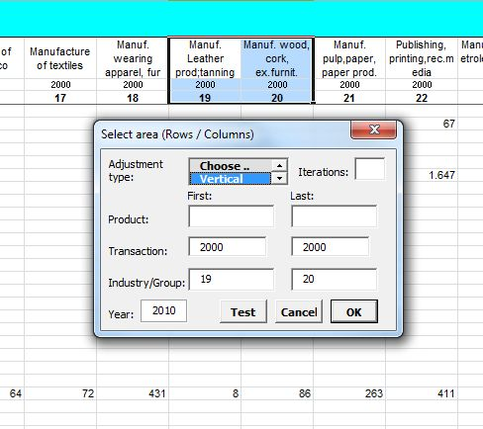
The entire columns for industry 19 and 20 are selected for vertical adjustment to targets. For columns on the uses side margins and taxes are recalculated. Columns with a “Total” header are not adjusted, but as they contain “sum”-formulas they are automatically updated to show the changes in totals. Adjustment of column-totals to their targets will usually result in new differences between supply and use for a number of products.

- Horizontal. Example:
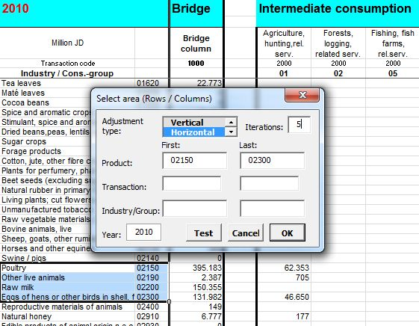

The entire rows from product 02150 to 02300 are selected for horizontal adjustment to supply.
As recalculation of margins and taxes may change supply in purchasers’ prices a complete adjustment of use to supply may require a number of iterations. In this example 5 iterations are chosen.

When rows are selected, pressing the “Vertical/Horizontal adjustments” –button opens a form that shows the selected range of rows. If the “Test” button on this form is pressed the default limits for columns included in the adjustment are shown. Notice, that the default selection will exclude the column for exports that should as a general rule remain unchanged by horizontal balancing. It is possible to override this choice by entering other values in the form except in cases where the selection includes multiple ranges. Values that cannot be changed are shown with a blue colour.

Columns that show totals for transaction codes contain “sum”-formulas. Hence the columns with a “Total”-header are updated automatically, but they are only indirectly affected by the balancing.

It is usually necessary to choose a suitable number of iterations. A number of iterations that is too small will result in an incomplete balancing. The process can be repeated with a new figure for iterations until the last remaining differences between supply and use are eliminated. In general it takes between 5 and 15 iterations to eliminate the differences.
Pressing the “OK” button on the form will start balancing of the selected area. When the calculation is finished, the cells that were directly included are marked with a red colour. “Total”-columns within the selection are coloured grey to show that they are only indirectly affected.

In some cases it is impossible to remove differences in this way. Balancing a product requires that the product-row contains values that can be adjusted by the value of the initial difference. This may not be possible, because adjustable uses are missing or because the uses that would need to be adjusted are predetermined. In such cases the product must be balanced manually.

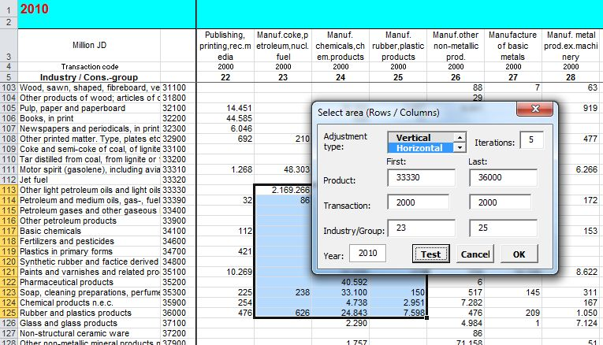

It is possible to limit the adjustment to one or more specific areas of the SUT as shown in the example above where a horizontal adjustment changes values within an area delimited by products 3330 to 36000 and input in industries 23 to 25.

Selection of the area that is included in an adjustment can take the form of multiple ranges. For a full description of possible selections, see below under the description of the button: “Selection tool”.

- RAS-area. Example:
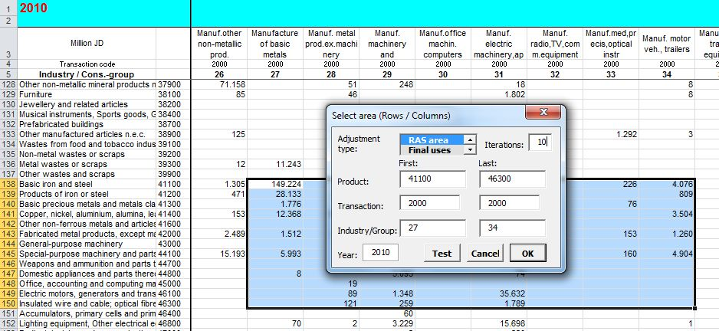

Here a sequence of vertical and horizontal adjustments is performed as many times as shown by the “Iterations” field.
Adjustment to row- and column targets is performed by changes within an area delimited by products from 41100 to 46300 and input in industries from 27 to 34. The number of iterations is chosen as 10.

It is possible to select a number of areas, for instance within intermediate consumption, household consumption and GFCF, that will be included in the adjustments to row- and column targets.

Generally after the calculation some – smaller – differences between column-totals and –targets will remain.

The “RAS”-area calculation keeps the sum of use at purchasers’ prices constant for each product while the redistribution moves values between the included columns. This will probably change some underlying margins and taxes and thus create some new differences between supply and use for a number of products. Such differences can – of course – be eliminated by a renewed horizontal balancing.

- RAS-total.
This method does the same as the “RAS-area” method with the modification, that the sums of use by products at purchasers’ prices are not kept constant during the redistribution. Instead the horizontal adjustment to total supply at purchasers’ prices is recalculated in each round of the calculation and the calculation finishes with a horizontal adjustment that usually removes remaining differences between supply and use.

- Final horizontal adjustment of all layers for uses to the values in the bridge column. Example:
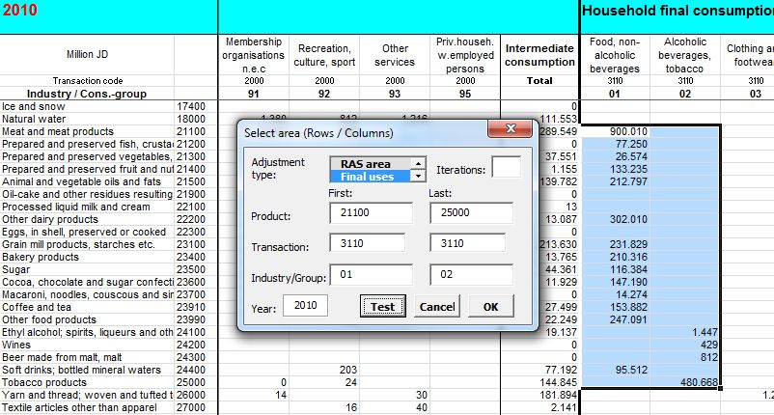

Adjustment is in this example limited to the area from product 21100 to 25000 and household final consumption groups from 01 to 02.

This facility should only be used when the final balancing is finalized as it replaces formulas with constant values. If – before the adjustment - the bridge column’s totals contain the correct values for total margins, net taxes and VAT, it will simultaneously – for all layers - remove any remaining differences between the supply and use. It may create a few new differences between column-totals and –targets that may need to be removed by final manual adjustment.

- Use >= Stat.
Within the selected area each value at purchasers’ prices is compared to its corresponding value in the “Primary-statistics” layer.
Where purchasers’ price is lower, it is replaced by the “Stat”-value. Where the purchasers’ price value is equal or close to the “Stat”-value it is marked as predetermined. This facility is used to avoid that values that has actually been reported to primary statistics are removed from these cells during subsequent vertical or horizontal adjustments. Before further adjustments, it may, however, be appropriate to manually remove some of the “predetermined” -markings from cells that have been marked by this procedure.

Fill layers below purchasers’ price. Performs a complete replacement of all formulas used for calculation of the layers from basic prices to VAT. Formulas for calculation of trade and transport margins, taxes on products and VAT are inserted where values have been entered in the purchasers’ prices layer on the uses side. Values already entered in these layers as constants are not replaced. Is used to insert such formulas in the initial version of the use table where values have been entered at purchasers’ prices. It can also be used to repair a use table if the formulas have been unintentionally overwritten.

Selection tool. Pressing the key has the effect that all cells with the same foreground colour as the presently selected cell are selected. The effect is the same as if the area in question was selected manually.

A manual multiple selection is made by holding down the Ctrl-button while selecting the areas in question. If a manual selection shall include several areas or isolated cells it will usually require a precise sequence of correct key-presses and movements of the pointer. It can be done with some skill, but it is much easier to use a colour to mark the cells that shall be included in the selection.

Using a colour it is possible to select or deselect areas before the selection is actually chosen. This is particularly useful when selections are made with the key “Vertical / Horizontal adjustment” that can restrict adjustments to non-contiguous selections of areas and cells within the uses side of the system.

There are various ways to select rows, columns, contiguous or non-contiguous areas. On the following pages are shown some examples of selections:

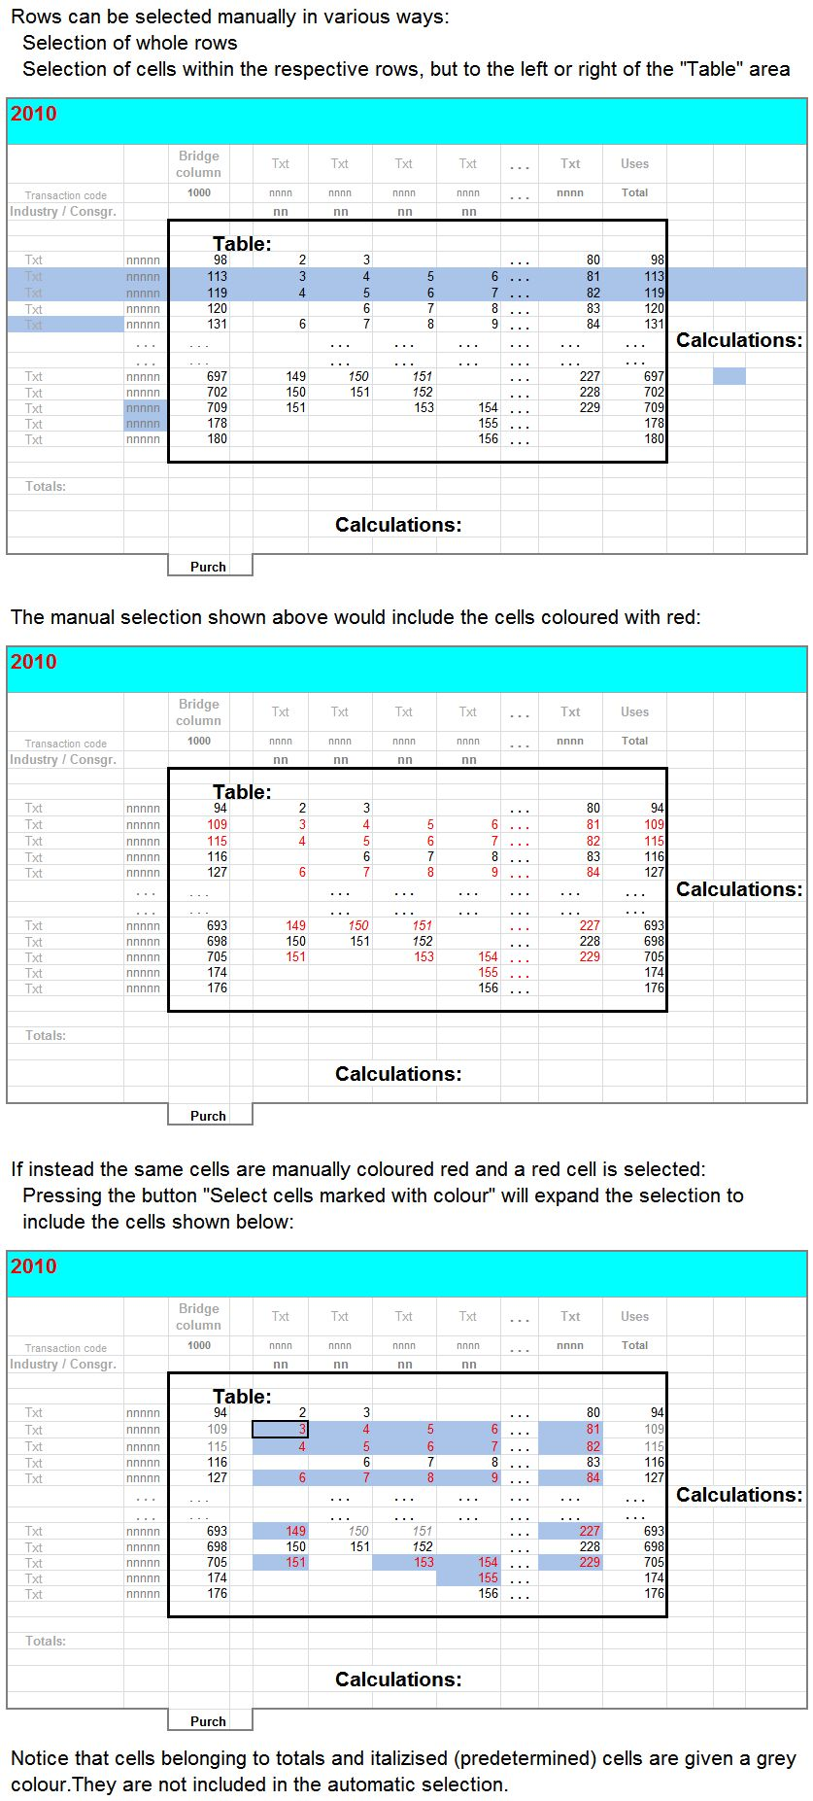
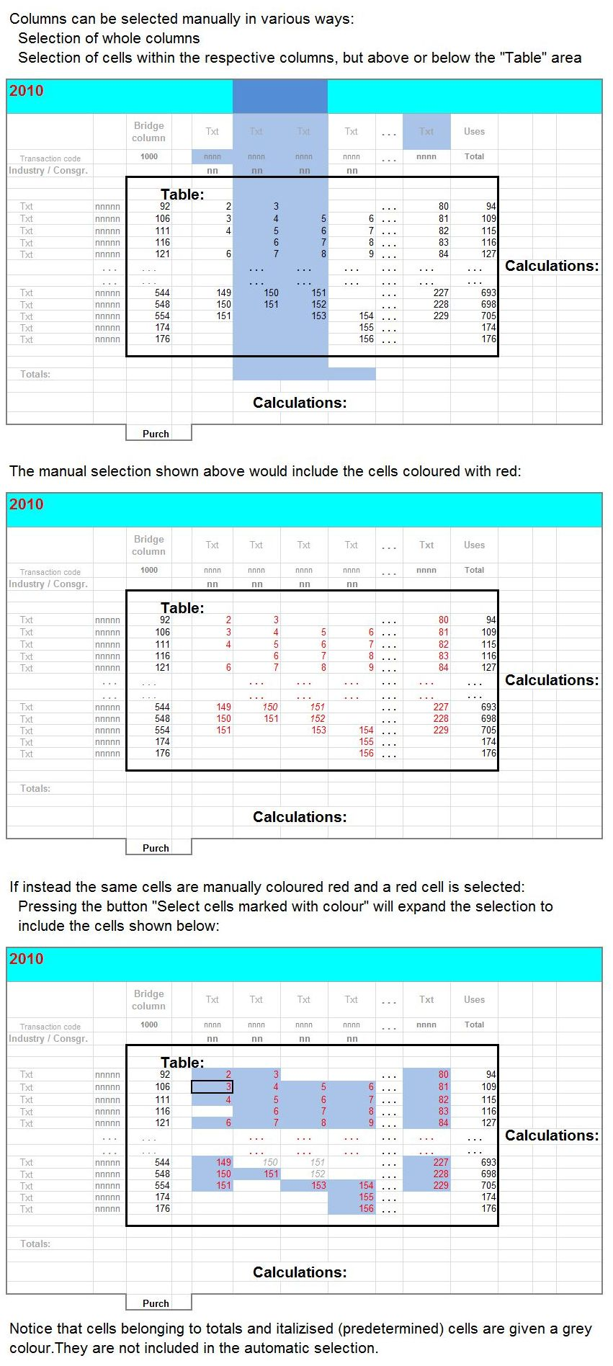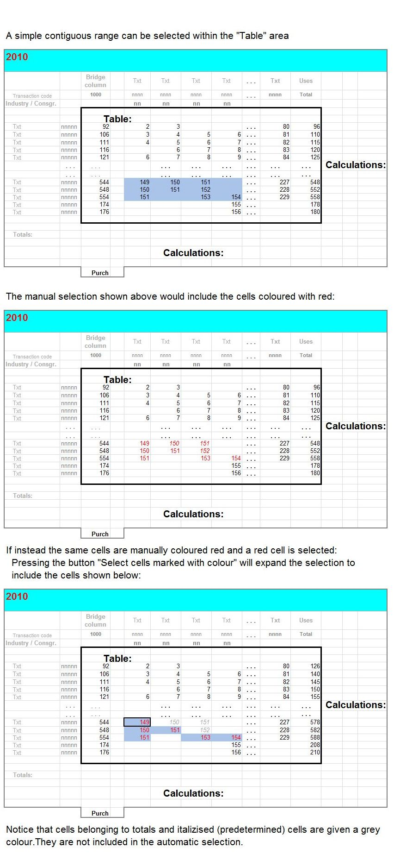
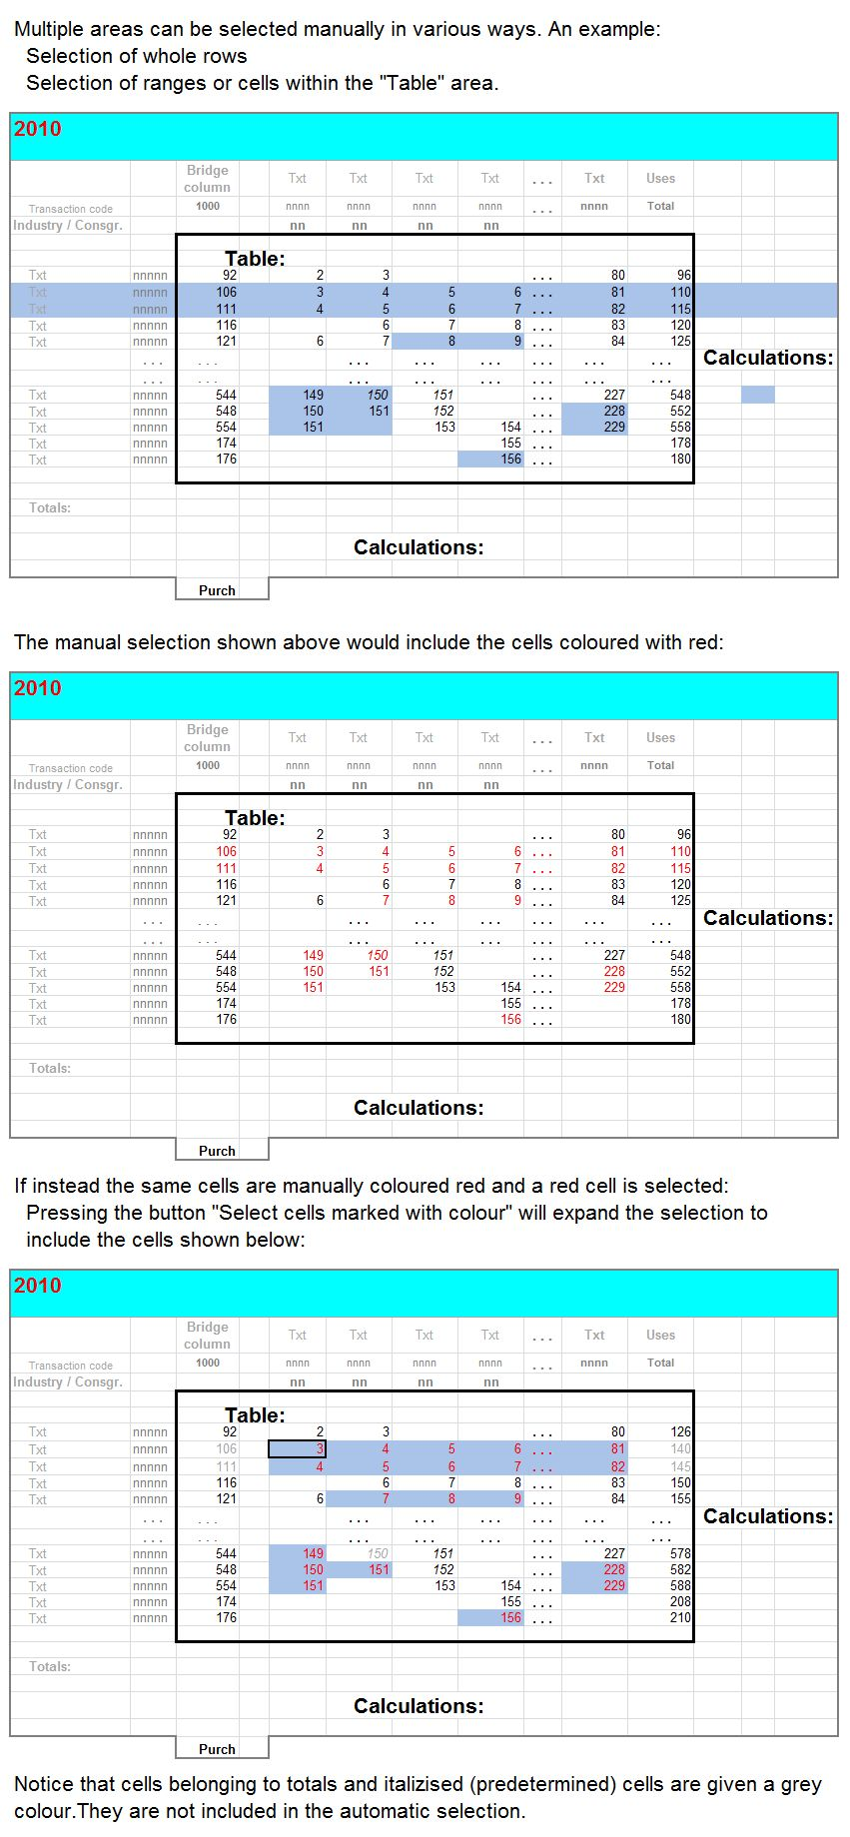
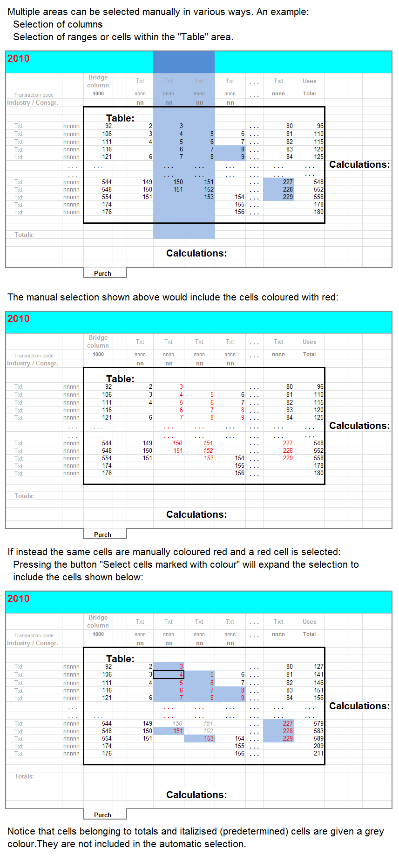

Read SUTs from flat textfile. Values are imported to the “selected SUT-workbook” from a textfile in the standardized format used by the Danish Pascal-programs.
The "selected SUT-workbook” is the one whose name has been entered in the “Personal Settings” -form (opened by pressing the -button). If it is not the active workbook at the moment, a warning is shown:
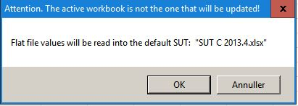
The textfile is opened by Excel as a workbook while the transmission of data takes place. If all records from the textfile find a place in the SUT-environment, this workbook is closed without any changes.
If the flat file should contain codes for products, transaction types or industries that do not have a place in the Excel SUT-environment, an error message is added to the right of each offending line, and the workbook remains open. A message is shown:
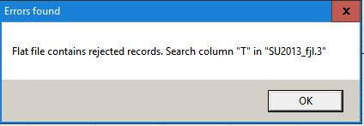
Before the selected SUT-environment is updated with values from the flat textfile, its cells are reset to zero and marked as non-predetermined values.

Write SUTs to flat textfile. Values are exported from the “selected SUT-workbook” to a textfile in the standardized format used by the Danish Pascal-programs.
The "selected SUT-workbook” is the one whose name has been entered in the “Personal Settings” -form (opened by pressing the -button). If it is not the active workbook at the moment, a warning is shown:
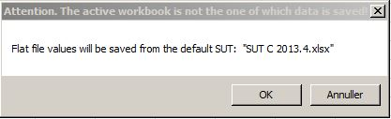

The content of the selected SUT-environment is transformed into a file with the format that is shown below. Each record contains values from the layers for Basic prices, wholesale trade and transport margins, retail trade margins, net taxes on products, VAT, Purchasers’ prices and reported values from primary statistics before any grossing up.
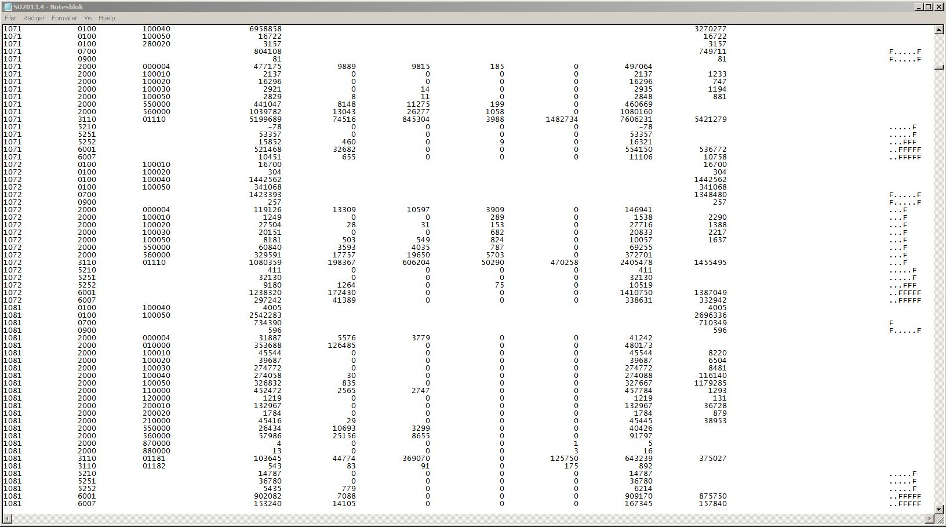

/
Shift language between Georgian and English product- , industry- and consumption codes.

