Foretag indberetningen online på
www.dst.dk/smv
Når du indberetter online, får du hjælp undervejs.
ENGLISH TRANSLATION IS INSERTED IN RED.

The questionnaire can be returned pr. mail to ata@dst.dk.
Thank you!

Statistik: | Små virksomheders aktiviteter  Activities in small enterprises 2022
Periode: | Årlig
Kontakt: | Information om denne indberetning: http://www.dst.dk/smv
 | Spørgsmål til indberetningens indhold: www.dst.dk/sos
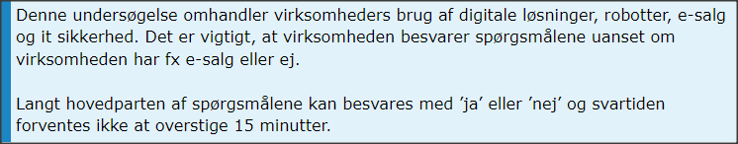
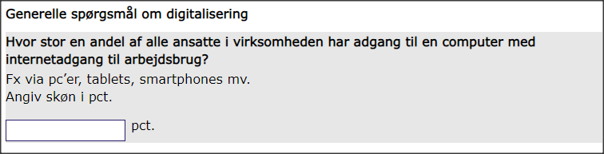
What is the share (pct.) of employees with access to a computer/smartphone/tablet with internet access in the enterprise? Please write a pct. share. E.g. 100 pct.

-------------- pct.

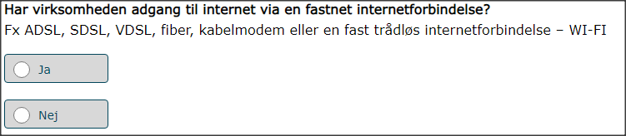
Does your enterprise have fixed internet access e.g. fiber, cabel modem, fixed wireless (WIFI)? Please write yes or no.

--------------

Hvis ’Ja’ til ovenstående skal følgende spørgsmål besvares
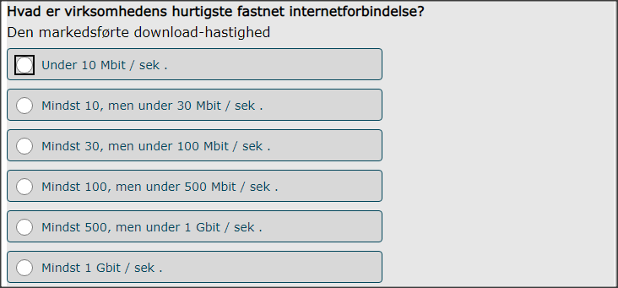
What is the max speed of your fixed internet access? Please write the speed in Mbit or Gbit/sek, see the list above.

--------------
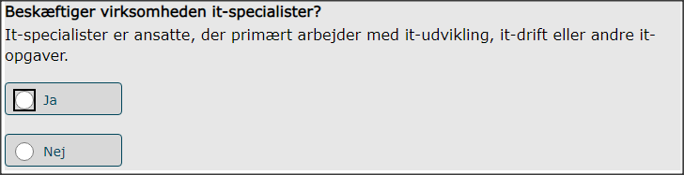
Does your enterprise it specialists? Please write yes or no.

--------------

Hvis ’Ja’ til foregående spørgsmål skal følgende spørgsmål besvares
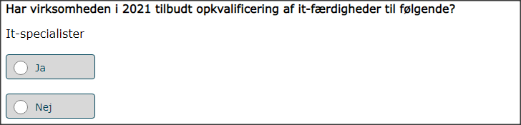
Answer only if you employ it specialists. Did your enterprise offer it related training in 2021
- to it specialists? Please write yes or no. --------------
- to other employees (not it specialists ) Please write yes or no. --------------

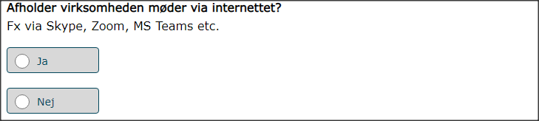
Does your enterprise have meetings via internet e.g. skype, zoom, teams, etc.?
Please write yes or no.
--------------
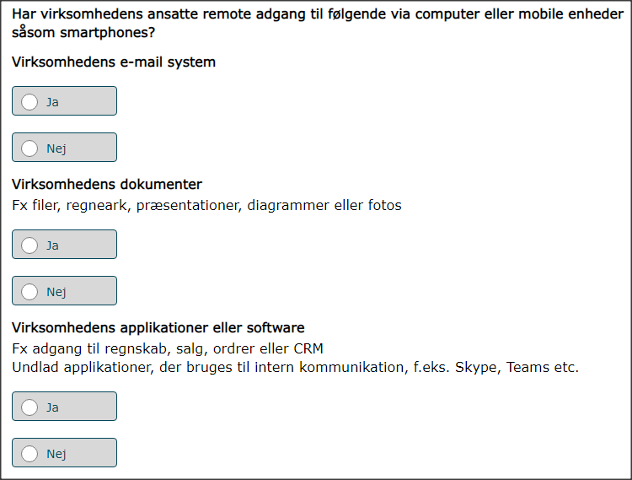

Do employees have remote access to the following?
- E-mail. Please write yes or no. ________
- Documents. Please write yes or no. ________
- Apps or software used by the enterprise. Please write yes or no. ________

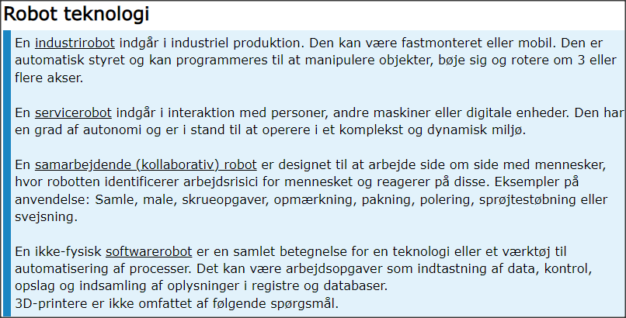

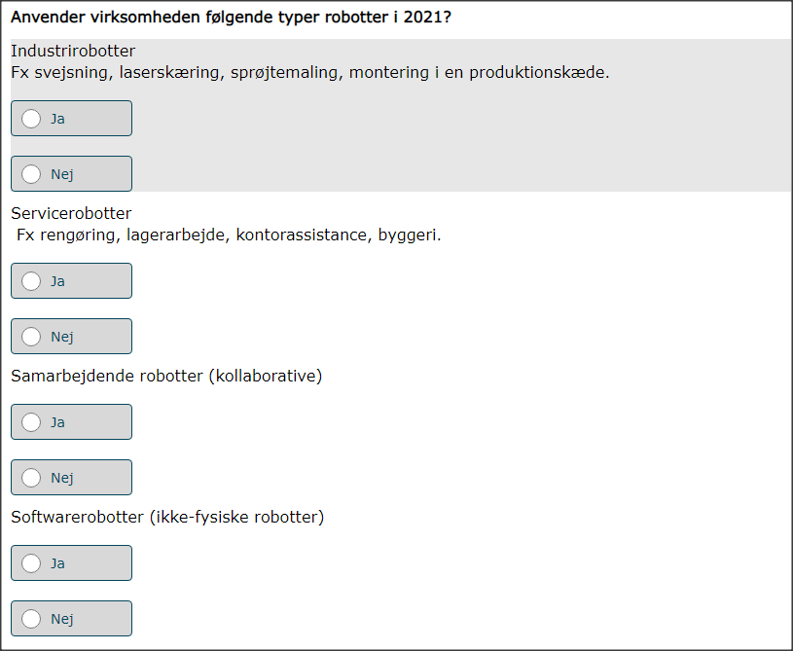

Does your enterprise use any of the following types of robots?
- Industry robots e.g. in assembly, painting, cutting etc.
Please write yes or no. ________
- Service robots e.g. cleaning tasks, logistics, warehouse tasks.
Please write yes or no. ________
- Collaborative robots e.g. robots that work together with humans.
Please write yes or no. ________
- Software robots e.g. not physical robots . E.g. virtual assistants, RPA, robotic process automation, data analysis.
Please write yes or no. ________

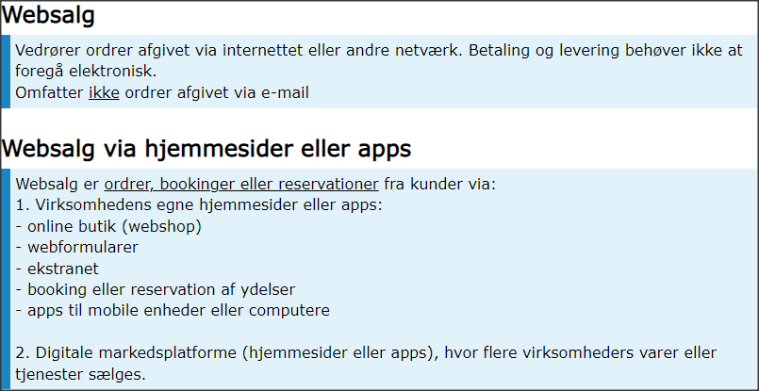
web-Sales is defined as sales based on orders placed via the Internet or other computer networks. The questionnaire covers two web-sales channels:
A. own website, webshop / app,
B. digital marketplaces where several companies' products are sold e.g. Zalando, ebay, Amazon or similar.

Payment or delivery does not need to be electronic, but the order should be placed via the internet. E.g. orders of take away food prepared by the enterprise or booking of service, etc. should be included.
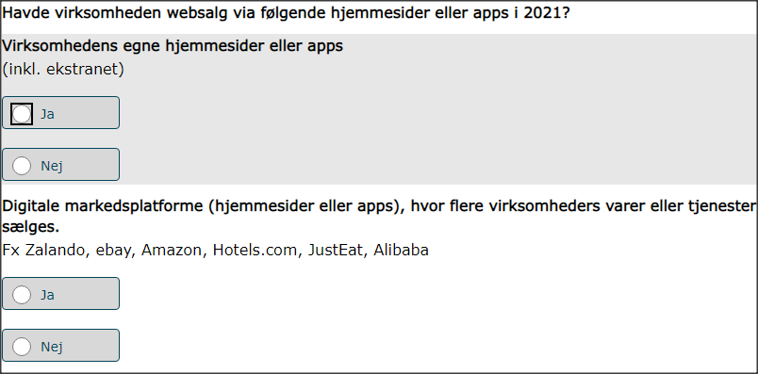
Did your enterprise have web sales of goods or services via the following sales channels in 2021?
- A. own website / app. Please write yes or no. ________
- B. digital marketplaces. Please write yes or no. ________

Hvis ’Ja’ til mindst ét af ovenstående spørgsmål skal følgende tre spørgsmål besvares
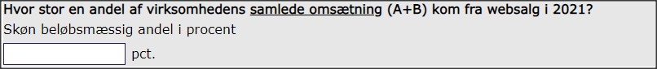
What percentage of the total turnover was generated via web-sales in 2021 (either via own website/apps or platforms)? Please aswer with a number between 0 and 100 if you have at least one ‘yes’ in the previous question. __________ pct.
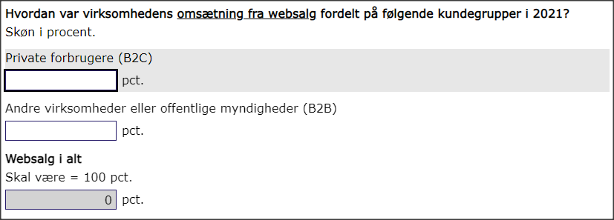
What is the share of the total web-sales in 2021 for the following customers?
Estimate in percentage. The sum of the two shares must be = 100 per cent.
- Sales to private consumers (B2C) _________ pct.
- Sales to other enterprises (B2B) and Sales to public sector (B2G) ___________ pct.
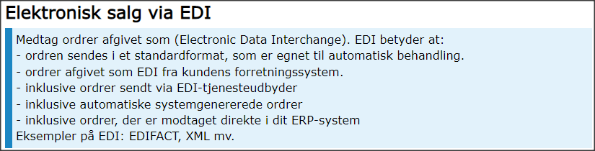
EDI (Electronic Data Interchange). EDI means that the order is sent in an agreed format, which allows automatic data processing (EDIFACT, XML, etc.) and that the individual order is not entered manually.
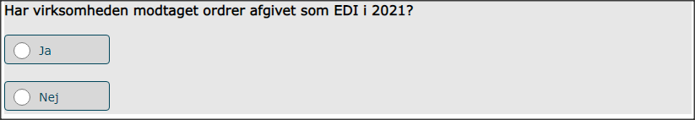
Did your enterprise have EDI sales of goods or services in 2021?
Please write yes or no. ________

Hvis ’Ja’ i foregående spørgsmål skal følgende spørgsmål besvares
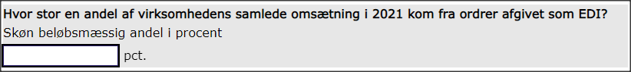
What percentage of the total turnover was generated via EDI sales in 2021? Please aswer with a number between 0 and 100 if you have said ‘yes’ to EDI sales in the previous question. __________ pct.

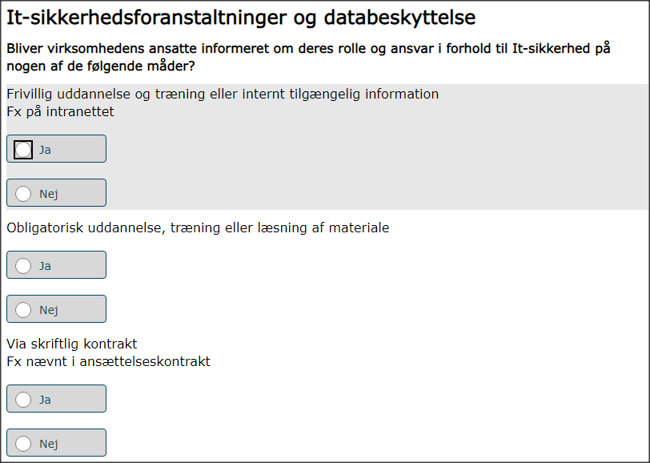
Does your enterprise make its employees aware of their obligations in ICT security related issues in the following ways?
a) Voluntary training or internally available information (e.g. information on the intranet)
Please write yes or no. ________

b) Compulsory training courses or viewing compulsory material
Please write yes or no. ________

c) By contract e.g. contract of employment
Please write yes or no. ________

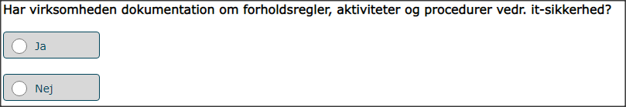
Does your enterprise have document(s) on measures, practices or procedures on ICT security? Please write yes or no. ________

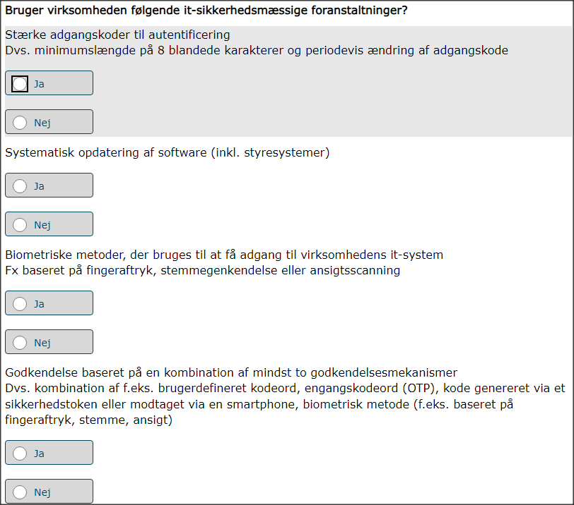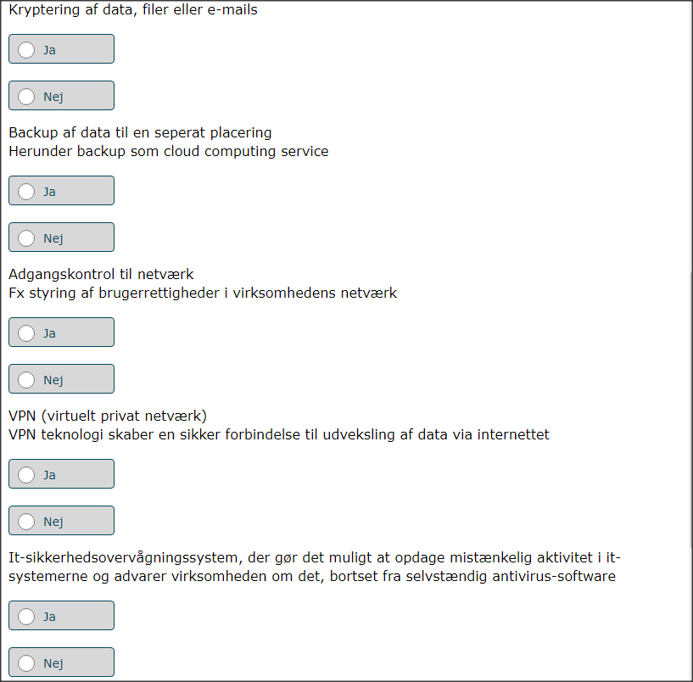
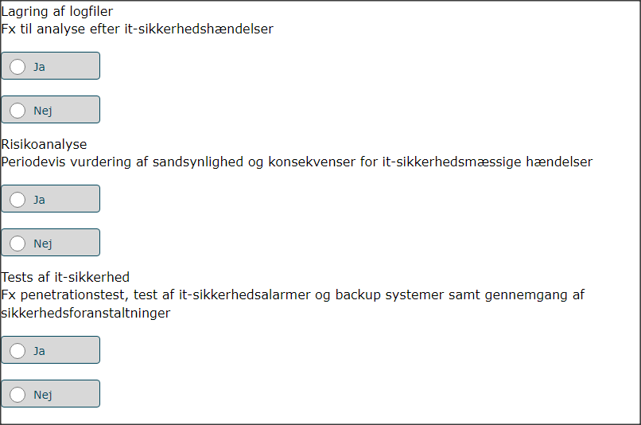
Does your enterprise apply any of the following ICT security measures on its ICT systems?
- authentication via strong password. (e.g. minimum length, use of numbers and special characters, changed periodically, etc.)
Please write yes or no. ________
- Systematic updating of software (incl. operating systems)
Please write yes or no. ________
- authentication via biometric methods used to access the enterprise’s ICT system. (e.g. authentication based on fingerprints, voice, face)
Please write yes or no. ________

d) authentication based on a combination of at least two authentication mechanisms. i .e. combination of e.g. user-defined password, one-time password (OTP), code generated via a security token or received via a smartphone, biometric method (e.g. based on fingerprints, voice, face)
Please write yes or no. ________

- Encryption of data, documents or e-mails
Please write yes or no. ________
- Data backup to a separate location (including backup to the cloud)
Please write yes or no. ________

- Network access control (management of user rights in enterprise’s network)
Please write yes or no. ________

- VPN (Virtual Private Network extends a private network across a public network to enable secure exchange of data over public network)
Please write yes or no. ________

- ICT security monitoring system that allows to detect suspicious activity in the ICT systems and alerts the enterprise about it, other than standalone anti-virus software
Please write yes or no. ________

- Maintaining log files that enable analysis after ICT security incidents
Please write yes or no. ________

- ICT risk assessment, i.e. periodical assessment of probability and consequences of ICT security incidents
Please write yes or no. ________

- ICT security tests (e.g. performing penetration tests, testing security alert system, review of security measures, testing of backup systems)
Please write yes or no. ________

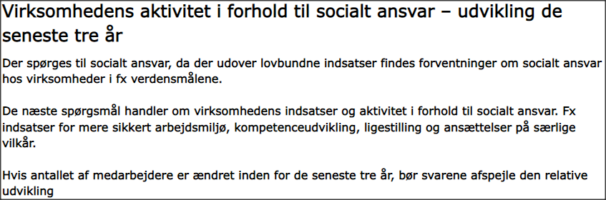
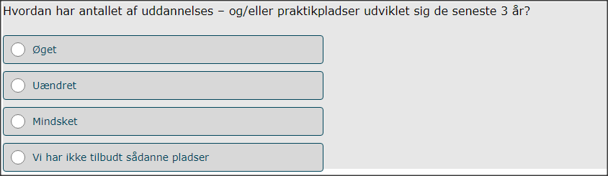
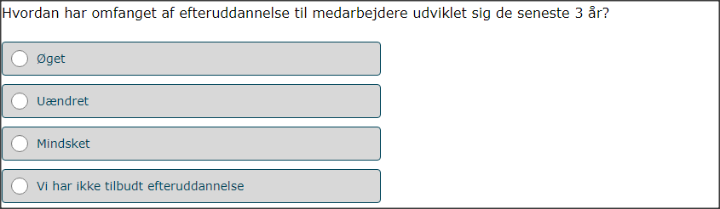
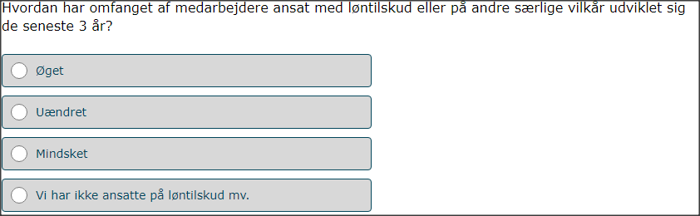
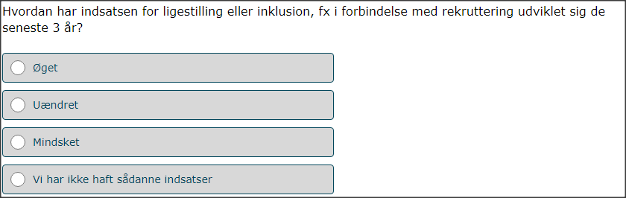
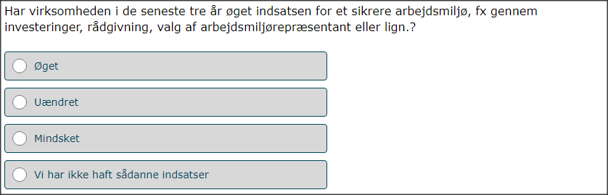
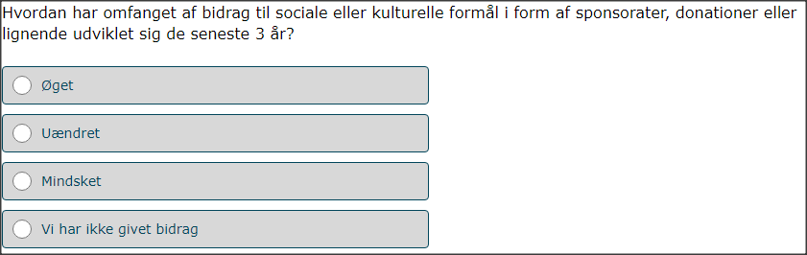
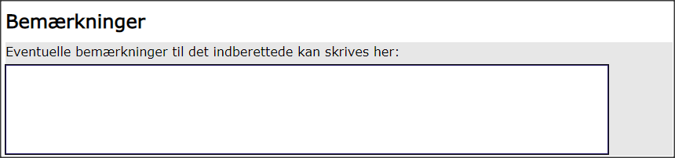
Social responsibility in business, also known as corporate social responsibility (CSR), pertains to people and organizations behaving and conducting business ethically and with sensitivity towards social, cultural, economic, and environmental issues.
How is the development in the number of trainee or apprentice places in your enterprise during the past 3 years. Please mark one answer.
- Increased /higher
- The same / no change
- Decreased /lower
- The enterprise has no positions for trainees or apprentices

How is the development in the number of employees sent to training or other education in your enterprise during the past 3 years. Please mark one answer.
- Increased /higher
- The same / no change
- Decreased /lower
- We do not offer training to employees

How is the development in the number of employees with wage subsidy or other special arrangements in your enterprise during the past 3 years. Please mark one answer.
- Increased /higher
- The same / no change
- Decreased /lower
- We do not have positions with wage subsidy

How have efforts for equality (e.g. of men/women) or inclusion, e.g. in connection with recruitment, developed over the past 3 years?
- Increased /higher
- The same / no change
- Decreased /lower
- We have not had such efforts

How have the efforts for a safer working environment, e.g. in the form of new processes, health initiatives, election of a working environment representative or the like. developed in the past 3 years?
- Increased /higher
- The same / no change
- Decreased /lower
- We have not had such efforts

How has the scope of contributions to social or cultural purposes in the form of sponsorships, donations or the like developed over the past 3 years?
- Increased /higher
- The same / no change
- Decreased /lower
- We have not made such contributions

